**DESIGN AND IMPLEMENTATION OF A TELEMETRY SYSTEM FOR MOTORSPORT APPLICATIONS USING CONTROLLER AREA NETWORK COMMUNICATION**

*An Undergraduate Project Report submitted to Manipal University*

*Submitted by*

**ADITYA VIKRAM JINDAL VARUN SACHDEVA**

(Reg. No 140907320) (Reg. No 18932522)

BACHELOR OF TECHNOLOGY

In

ELECTRONICS AND COMMUNICATION ENGINEERING

And

ELECTRONICS AND INSTRUMENTATION ENGINEERING

**MANIPAL INSTITUTE OF TECHNOLOGY**

**INTRODUCTION**

This project report describes the design and working of a Motorsport Data Acquisition System and Live Telemetry System developed using the Controller Area Network (CAN) communication protocol as the backbone of the system. A Formula One car hosts over a hundred sensors during each of its races. The Data Acquisition System, although does not directly affect the car’s performance, is an indispensable system when it comes to improving and testing designs. Designers can validate their assumptions and calculations, real-time data during testing can be a safety indicator and it provides insight to the driver about the performance of the vehicle.

**OBJECTIVES**

The proposed work is to design and implement a Data Acquisition and Telemetry System to be on-board a race car. The major objectives include

* Establish a modular Controller Area Network bus which runs throughout the vehicle.
* Interfacing multiple nodes to the said CAN bus, each with their own functionalities.
* Transmitting the data of multiple sensors onboard the vehicle.
* Display valid data to the driver while operating the car.
* Wireless data transmission back to host across a long range.

**SYSTEM OUTLINE**

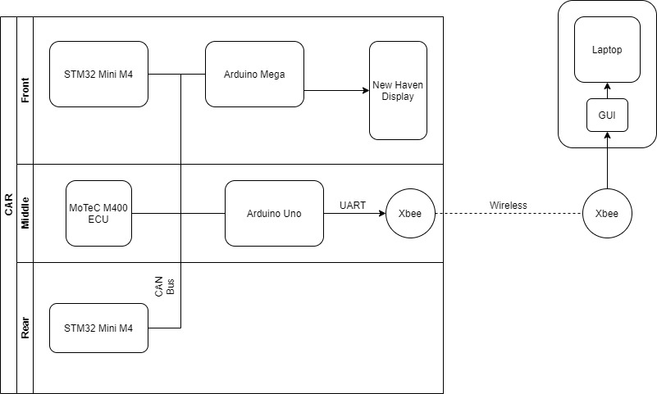

**COMPONENTS**

1. **MoTeC M400 ECU**
2. **STM32 Mini M4**

The STM32 Mini M4 is a development Board fitted with STM32f415RG microcontroller powered by ARM cortex. The board comes fitted with 15 Analog Input Pins and an inbuilt CAN Controller. The system Utilises 2 such boards, one positioned in the front and one in the rear of the vehicle, to collect data from all the non-engine sensors (ECU sensors), format them into appropriate CAN messages and transmit them onto the CAN bus.

1. **Arduino Uno**
2. **Arduino Mega**
3. **Xbee Pro 900 Hp**
4. **New Haven Display**
5. **Graphical User Interface**